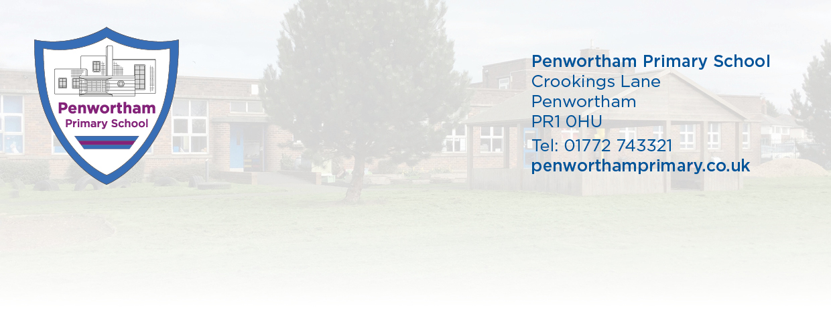

Dear parents and carers,
We are very much looking forward to having school open to all year groups in September when as you will be attendance will again be mandatory. Staff have been very busy planning lots of exciting learning and getting classrooms looking fantastic so that we have a brilliant start to the new school year. I am especially looking forward to meeting everyone and getting to know all our school families.
This letter contains important updated information regarding what will happen when your child returns to school. Your child’s mental health, well-being and safety are of paramount importance. We all want our children to have a happy experience in school and will do our utmost to create a safe environment for everyone.
In school we are minimising risks but know that we cannot remove all risks. We have made significant changes to the school environment and introduced some new routines. This includes use of social distancing, reducing contacts and high standards of hand and respiratory hygiene. You can help by talking to your child about what to expect when they come back to school. Below are some of the changes your child should expect:
The school environment:
Pupils will each belong to their own year group class bubble. In class children will have their own set of stationery to reduce sharing of resources. Some resources will be shared within the class bubble but will not be shared across class bubbles.
Desks will be forward facing and teachers will try to maintain distance from children as far as possible. Activities such as singing and indoor PE will not take place with the full class indoors. There will be no whole school assemblies.
Children may share toilets with other bubbles but we will reduce risk of transmission by controlling the number of children entering the toilets at any one time and promoting high standards of hand hygiene.
Each class bubble will have their own playground area (on a rota basis) and play resources which will not be shared with other class bubbles.
Contact with other class bubbles will be minimized. Some staff will work across class bubbles but will follow the strict hygiene measures for hand washing and disinfecting.
The Curriculum:
We are aware our children will have had very different experiences over the last few months and we are adapting our curriculum to take account of this. There will be increased time spent on personal, social and health education.

We will review pupils’ progress and aim to fill any gaps in their learning of core concepts and skills as well as working towards the end of year age related expectations.
Some staff will be part of a dedicated ‘Bounce Back’ team to support children in their learning.
In addition, we will be planning a contingency curriculum in the event that should there be a further full or partial lockdown to ensure that all our children have access to high quality teacher led learning at home.
During the first half term we will offer reduced extra curricular clubs whilst everyone adjusts to the new arrangements. We hope to offer a wider range of extra curricular clubs through the remainder of the year and will issue information later in the new term.
Daily routines:
We will be pracitising social distancing as far as is possible within a school with children. Regular handwashing or sanitising will be routine.
Windows and doors will be kept open all day to allow good ventilation. Please ensure your child has their jumper and layers to keep warm.
Reading books will be subject to a quarantine time and your child’s class teacher will inform you of how this will work. We will not always be able to send new books home on the same day as they are returned to school.
Cloakrooms will be open but please do not send any unnecessary equipment into school. PE uniform should not be sent into school. We will advise you in due course of PE days for your child and on these days children will be able to attend school in PE kit with grey or black joggers and trainers and school sweatshirt. This will reduce the amount of time children spend changing (and therefore more time learning) and reduce possible contact points.
Hygiene
We will promote regular handwashing. We have good stocks of handwash and hand sanitiser. Please let us know if your child has any allergies to these. If your child requires hand moisturiser it may be brought into school if absolutely necessary but this must be named and your child must keep it with them. They must understand that it cannot be shared with other children.
We have an enhanced cleaning schedule in operation with additional cleaning mid morning and mid afternoon as well as full school cleaning at the start and end of the day.
Uniform
Full school uniform should be worn but we ask that you try to wash it as often as possible to reduce any cross contamination. Please avoid elaborate hair accessories and ensure that long hair is tied back. Wearing full school uniform is an important part of having a sense of belonging to our school family. Our school website details the uniform policy.
Face coverings are not required for children in primary school.
Pupils should bring in named sunscreen and a hat for outdoor learning activities and playtimes if the weather is hot. Please help your child understand how they can apply this themselves and ensure that it is applied at home before school.
Food and lunchtimes
Children may bring a snack of fruit or vegetables for eating at break time. At this point we are not able to offer toast at playtime but this will be reviewed. Children should not have crisps, cakes, biscuits, sweets etc as their morning snack.
We are able to offer a hot or cold lunch option from the school kitchen in the first half term. For pupils in reception, Year 1 and Year 2 these are free of charge. We will be operating a staggered lunchtime from 11.30-1.30 in order to provide every child with time to eat their lunch in the dining room. Tables and chairs will be disinfected between each class bubble.
Children not wanting a school lunch should bring their packed lunch bag and all pupils should have a named water bottle.
Arriving and Departing
The school term begins on Wednesday 2nd September 2020. Classes are open from 8.45am for morning activities and school starts at 8.55am. School will close at 3.30pm We will be using all the school entrances and exits to reduce congestion. Please follow social distancing guidelines if you are waiting with your child. In order to keep all members of our school family as safe as possible we ask that adults wear a face covering when on school grounds.
Only 1 adult should accompany a child to school and children must use the correct entrance and exit each day. Please avoid travelling by vehicle if at all possible.
Some of our younger children may be distressed at drop off time as they are so used to being at home. Please try to prepare them for returning to school and share with them what will happen as they are dropped off. At the drop off point they will need to walk into school independently. As a parent you will not be able to enter the school building. Staff will be able to encourage children to come into school but will not be able to come and take your child from you to bring them into school.
Pupils should use the following entrances and exits:
Reception: Meadway entrance
Year 1 pedestrian entrance on Crookings Lane through the gate and into school via the library door. Pupils will be collected from the library door
Year 2 pedestrian entrance on Crookings Lane through the gate and into school via the library door. Pupils can be collected via this entrance and will be waiting in the outdoor classroom.
Year 3 Crowhill Road entrance. Pupils can be collected from the small playground at the end of the day (by the table tennis tables)
Year 4 Crowhill Road entrance. Pupils can be collected from the small playground (near the hall entrance)
Year 5 Crowhill Road entrance. Pupils can be collected from the Year 5 entrance.
Year 6 – pedestrian entrance on Crookings Lane, through to Year 6 side door classroom entrance.
Please DO NOT bring vehicles onto the car park between 8.45am and 3.45pm.

Health and well being
Children can only attend school if they are fit and well. If a child is in anyway unwell they MUST stay at home. If a child shows any signs of being unwell with symptoms of Covid 19 we will isolate that child from the rest of their class bubble and ask you to collect them as soon as possible. We will do all we can to re-assure them.
If any member of your household shows symptoms of Coronavirus you MUST inform school and the rules for self isolation must apply to the household.
Pupil well being and understanding feelings and emotions will be a priority in our teaching and learning. We know that your family may have been affected in different ways over the past few months. It there are issues that you feel we should be aware of please contact your child’s teacher, Mrs Gaskell (Deputy Head) or Mrs Hesketh (Headteacher).
To reduce the risks of contact there will be no access to the school building except by appointment. This includes the school office and all communication will be through the School office or email with your child’s teacher. If you wish to speak to a member of the Senior Leadership team please contact the school office.
We have made some changes to the school policies on behavior and safeguarding. These are available on the school website.
Private external providers of before and after school care should also operate under the government guidelines provided and be able to provide parents with information regarding Covid 19 risk assessments.
We are all looking forward to having a school full of happy children and thank you for your support.

Helen Hesketh

Mrs Helen Hesketh
Headteacher

