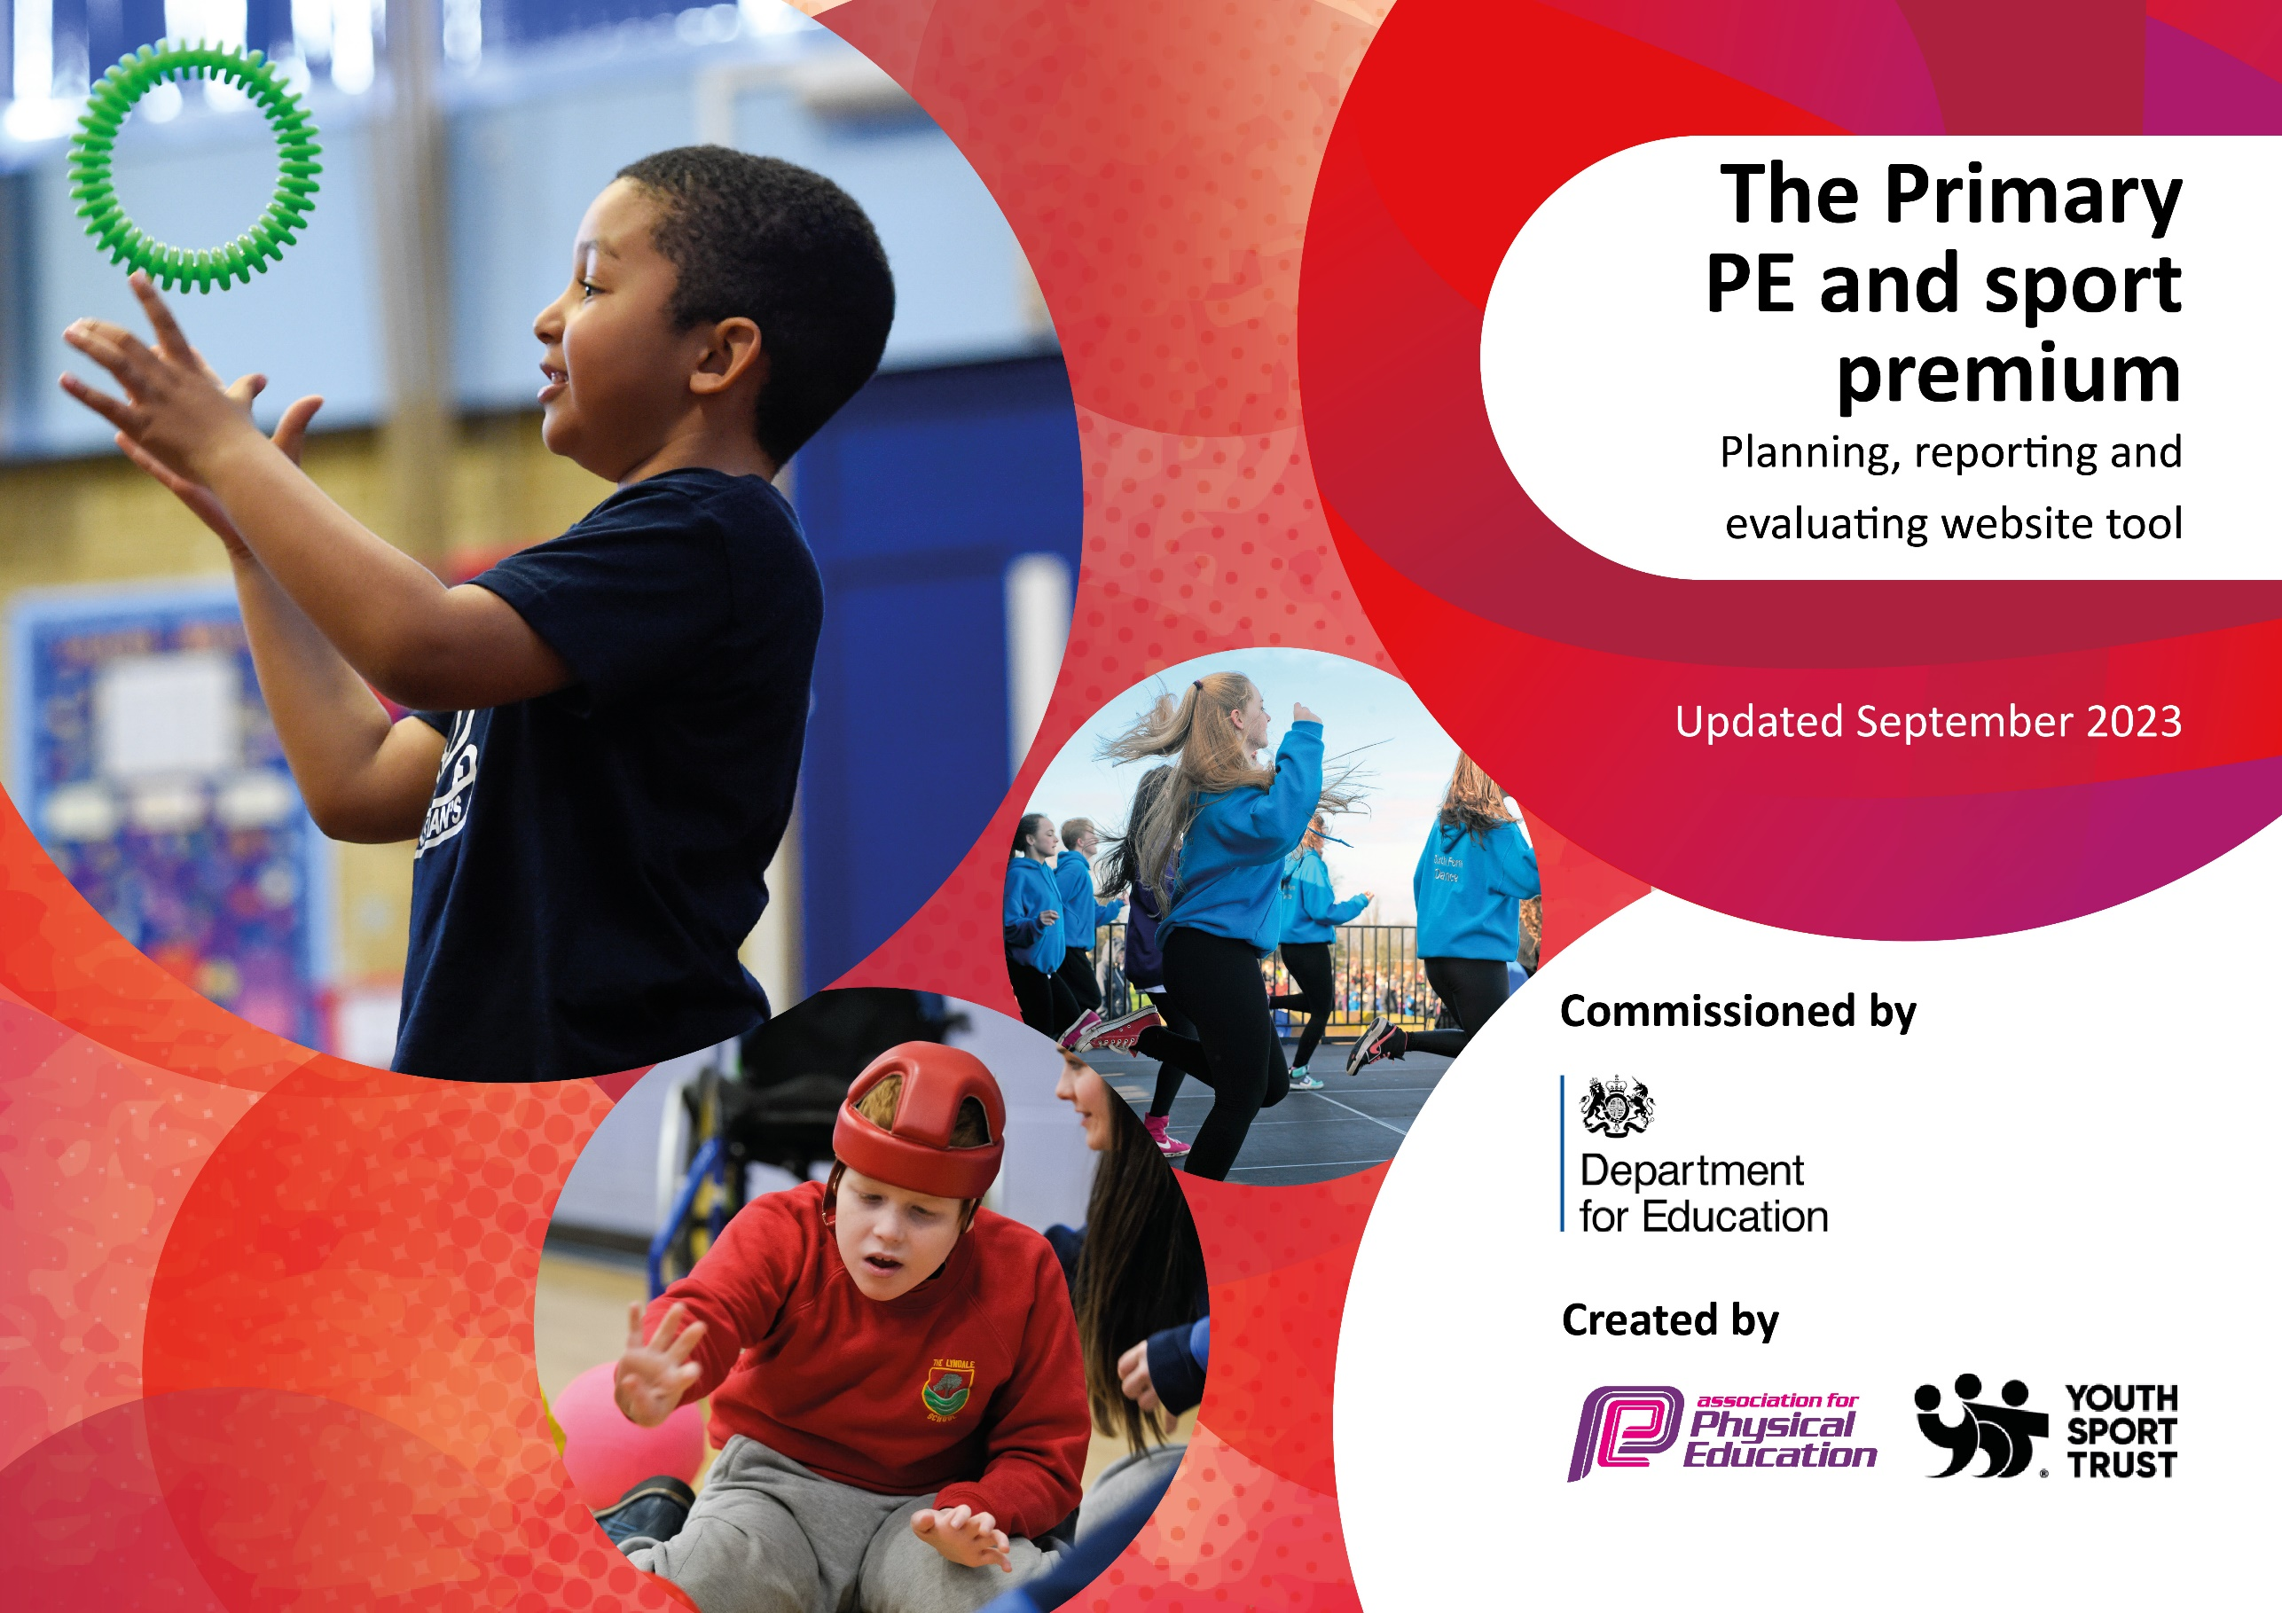

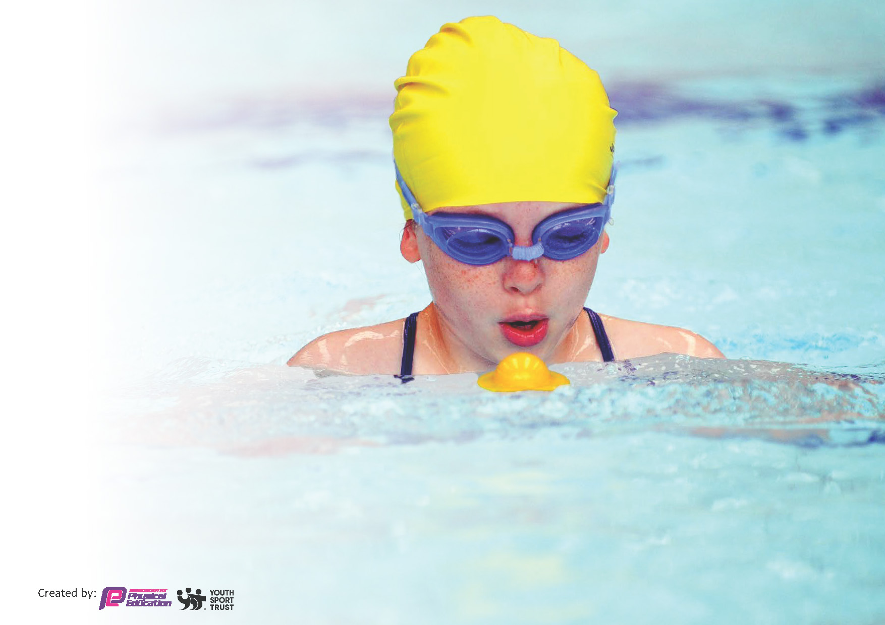
This template can be used for multiple purposes:
by:
- It enables schools to effectively plan their use of the Primary PE and sport premium
- It helps schools to meet the requirements (as set out in guidance) to publish information on their Primary PE and sport premium
- It will be an effective document to support Ofsted inspections enabling schools to evidence progress in Physical Education (PE) and evidence swimming attainment, which forms part of the PE National Curriculum. We would recommend schools consider
the Intent, Implementation and Impact of any spend, as examined within the Education Inspection Framework.

It is important that your grant is used effectively and based on school need.

Schools must use the funding to make additional and sustainable
improvements to the quality of the PE, School Sport and Physical Activity (PESSPA)
they offer. This means that you should use the Primary PE and sport premium to:

- Build capacity and capability within the school to ensure that improvements made now will benefit pupils joining the school in future years
- Develop or add to the PESSPA activities that your school already offers.

The Primary PE and sport premium should not be used to fund capital spend projects; the school’s core budget should fund these. Further detail on capital expenditure can be found in the updated Primary PE and sport premium guidance.

The Primary PE and sport premium guidance, outlines 5 key priorities that funding should be used towards. It is not

necessary that spending has to meet all the key priorities, you should select the priorities that you aim to use any funding towards.

Although completing this template is not a requirement for schools, schools are required to publish details of how they spend this funding. Schools must also outline what the impact this funding has had on pupils’ PE and sport participation and attainment and how any spending will be sustainable in the future. All funding must be spent by 31st July 2024.

The Department for Education has worked closely with the Association for Physical Education (afPE) and the Youth Sport Trust (YST) to develop this template and encourages schools to use it. This template is an effective way of meeting the reporting requirements of the Primary PE and sport premium.
Review of last year’s spend and key achievements (2022/2023)

We recommend you start by reflecting on the impact of current provision and reviewing your previous spend.

Activity/Action | Impact | Comments
- Pupils to have opportunities to participate in extra-curricular activities on a wide range of skills.  - Improve engagement of pupils during physical activities.  - Develop outdoor playground activities during lunchtime and ‘active break’ time.  - Maintain high profile of PE in school by increasing number of pupils attending activities such as extra-curricular activities, festivals, local and regional competitions.  - Employ and develop Play leaders and Sports Leaders to increase participation of pupils in active sessions.  - Implement PE Passport planning and assessment App.  - Develop staff confidence in teaching sports within year groups through CPD, specialist teaching and team teaching where possible.  - Staff to participate in all activities led by Specialist Sports Coaches such as weekly curriculum delivery sessions and/or festival days in order to develop own skills and confidence.  - Extend the opportunities for after school activities led by specialist coaches from SRBC  - Extend the opportunities for skills to be introduced through festival taster days led by SRBC.  - Access to the local Sports competition infrastructure, giving access to a wide range of local competitions and events which can lead to regional and national escalation, through the School Games project.  - Access to friendly local sport competitions.  - Maintain participation in events throughout the year – including intra-school events within school – class-class and within each class during lessons.  - Take inspiration from others to form aspirations to gaining sporting achievements. | - Higher engagement in physical activities. Higher participation during lessons, lunchtime and regular active minutes during afternoon break times.  - All classes have 2 PE sessions per week.  - Some classes engaged in skill-based breaks to develop fundamental skills related to curriculum expectations.  - Vast majority Year 6 gained swimming expectations.  - Festival days have been a success and all pupils have engaged.  - Attended numerous sports events and competitions.  - Attended new competitions this year – Girls football league, Netball league and Summer Sports borough event.  - High attendance of after school clubs – basketball, cricket, cheerleading, tag rugby, netball, football, tennis, fun target sports.  - PE passport training in staff meeting.  - Pupils identified and supported in lessons and focussed during sessions with SRBC.  - Pupils accessed Festival days delivered by SRBC.  - Inspiring coaches in school from GB athletes in Autumn.  - Football coaching with Mr Simms (y5 parent) and attended competitive league in both mixed and girls football held at Priory Academy.  - Netball team attended the Netball league at Priory.  - Tag rugby coaching from Mr Bremner (Y6 parent) and attended competitive league at Priory.  - Cricket coaching from Mr Bremner (Y6 parent) and attended Cricket day at Vernon Carus.  - Pupils also attended tennis day, KS1 event, athletics events and inclusion event. A range of children selected for the events to increase participation numbers and fairness. | - Continue to develop lunchtime activities.  - Continue to develop ‘active playtime’ for every class each day to include daily mile and skill-based time.  - Introduce incentives and celebrations for activity.  - Continue to ensure 2 PE sessions timetabled per week.  - Continue to engage with SRBC to hold after-school clubs aimed at year group specific objectives.  - House / Team competitions to promote active time.  - Continue to record participation and select low attenders to participate in events.  - Continue to attend inter schools competitions.  - Hold intra schools competitions between class-class.  - Continue to develop Sports leaders with new equipment and game ideas.  - Further CPD through SRBC and FA to gain confidence to encourage participation levels in all lessons.  - Develop own Forest school sessions – Forest school training for staff.  - Engage in specialist coached for future coaching of games such as cricket, tennis, football.  - Engage in specialist coaching for Gymnastics.  - Engage with SRBC for continued delivery of curriculum and ASC needs.  - Full use of PE Passport planning tool to ensure confidence in coverage of all content of the curriculum.  - Return to DDMix for Dance content.  - Extra-curricular sessions to match events in preparation for the events to include KS1 and focus on girls.

Key priorities and Planning
This planning template will allow schools to accurately plan their spending.

Action – what are you planning to do | Who does this action impact? | Key indicator to meet | Impacts and how sustainability will be achieved? | Cost linked to the action
- Each class able to access 2 sessions per week.  - Re-introduce daily activities such as ‘Active break’ time.  - Improve playground equipment.  - Pupils engage in lunchtime activities led by Y5/6 play leaders.  - Ensure pupil participation throughout the school in physical activities – registers.  - Identify those children who are below age-related expectations for fundamental development and co-operation skills.  - Implement Intervention for Fundamental Movement Development.  - After School club led by specialist coaches – RugbyTots, Pro-Skills soccer.  - 6 x after school club through the year led by SRBC Sports Coach.  - Half Termly Festival days led by SRBC Sports Coaches.  - Curriculum coaching led by specialist coaches – SRBC (Dance, Tennis, Gymnastics) RugbyTots.  - Attend Regional events led by SRBC and School Games Co-ordinator.  - Cluster competitions and Whole Borough led by SRBC Sports Coaches.  - Intra-School competitions – House/Team competitions throughout the year.  - Incentives such as celebrations assembly – link with gifted and talented.  - Pupils to take on roles of Sports Leader and Play leaders  - Employ TA (JW) to support physical activities during lunchtimes/ after school.  - Arrange visits from inspiring athletes to enhance pupils’ perception about sport.  - Engage in Intra Year Group House competitions – termly.  - Play leaders to lead competitive games during lunchtime activities.  - After School Clubs to train teams ahead of event. | Teaching staff / pupils  Pupils – be active more.  Lunchtime supervisors – better provision.  Teaching staff to assist EL monitoring registers.  Teaching staff – identify pupils  Teaching staff / Support staff – intervention during PE lessons.  Pupils – more opportunities.  Teaching Staff / pupils – access to more sports.  Pupils – wider opportunities.  Teaching staff – gain experience / training / support. Pupils – gain quality coaching.  Pupils – more experiences/more active.  Pupils – wider opportunities.  Pupils – incentives / more exciting/ positive opportunities.  Pupils – leadership opportunities  Younger pupils - new opportunities to be more active in games at lunchtime. | Key indicator 1: The engagement of all pupils in regular physical activity – Chief Medical Officers guidelines recommend that primary school pupils undertake at least 30 minutes of physical activity a day in school  Key indicator 2: The profile of PESSPA being raised across the school as a tool for whole school improvement  Key indicator 4: Broader experience of a range of sports and activities offered to all pupils  Key indicator 3: Increased confidence, knowledge and skills of all staff in teaching PE and sport  Key indicator 5: Increased participation in competitive sport  Key indicator 4: Broader experience of a range of sports and activities offered to all pupils  Key indicator 4: Broader experience of a range of sports and activities offered to all pupils  Key indicator 5: Increased participation in competitive sport | Timetable evaluated each half term. Most classes to have AM session as PM have impact from lunch clear-up and assembly time (so 45 mins per class in PM)  Lunchtime equipment purchased and Sports Leaders leading activities. Equipment needs replacing at a high rate.  Registers kept up to date. Gaps in attendance/participation to be reviewed Summer 1.  Interventions for FMD in Autumn term. Children identified to attend After School Club / events in Spring 2 and Summer 1. | £2,000 – lunchtime equipment  £1000 – Staff cost for intervention  £3,000 – cost for coaches to run after school club.  £1000 – cost for TA to run after school club.  £1000 – cost to SRBC for attending events.  £200 cost for training sports leaders.  £1000 – cost for visiting athletes.
- 2 x classes attend swimming and aim to bring swimming age to Year 4. | Pupils – gain swimming expectations prior to Year 5/6. Water confidence | Key indicator 4: Broader experience of a range of sports and activities offered to all pupils |  | £ cost for swimming

CPD for teachers. | Teaching staff – gain confidence.  Pupils – more access to different sports in lessons. | Key indicator 3: Increased confidence, knowledge and skills of all staff in teaching PE and sport | Primary teachers more confident to deliver effective PE supporting pupils to undertake extra activities inside and outside of school, including teaching water safety and swimming and as a result improved % of pupil’s attainment in PE. | £5000 for 5 teachers to undertake CPD.  LU attended Wellbeing coaching _ Autumn 1  CPD led by our School games co-ordinator – Autumn 2.  Wellbeing for pupils CPD led by SRBC coach – Autumn 2 to include Yoga for children.  CPD within DDMix scheme – including tutorials and videos for teaching Dance.

Key achievements 2023-2024
This template will be completed at the end of the academic year and will showcase the key achievements schools have made with their Primary PE and sport premium spending.

Activity/Action | Impact | Comments
- Each class able to access 2 sessions per week.  - Re-introduce daily activities such as ‘Active break’ time.  - Improve playground equipment.  - Pupils engage in lunchtime activities led by Y5/6 play leaders.  - Ensure pupil participation throughout the school in physical activities – registers.  - Identify those children who are below age-related expectations for fundamental development and co-operation skills.  - Implement Intervention for Fundamental Movement Development.  - After School club led by specialist coaches – RugbyTots, Pro-Skills soccer.  - 6 x after school club through the year led by SRBC Sports Coach.  - Half Termly Festival days led by SRBC Sports Coaches.  - Curriculum coaching led by specialist coaches – SRBC (Dance, Tennis, Gymnastics) RugbyTots.  - Attend Regional events led by SRBC and School Games Co-ordinator.  - Cluster competitions and Whole Borough led by SRBC Sports Coaches.  - Intra-School competitions – House/Team competitions throughout the year.  - Incentives such as celebrations assembly – link with gifted and talented.  - Pupils to take on roles of Sports Leader and Play leaders  - Employ TA (JW) to support physical activities during lunchtimes/ after school.  - Arrange visits from inspiring athletes to enhance pupils’ perception about sport.  - Engage in Intra Year Group House competitions – termly.  - Play leaders to lead competitive games during lunchtime activities.  - After School Clubs to train teams ahead of event.  - 2 x classes attend swimming and aim to bring swimming age to Year 4.  - CPD for teachers | - High engagement in physical activities. High participation during lessons, lunchtime and regular active minutes during afternoon break times.  - All classes have 2 PE sessions per week.  - Some classes engaged in skill-based breaks to develop fundamental skills related to curriculum expectations.  - All Year 6 gained swimming expectations. All Y4/5 gained expectations.  - Festival days have been a success and all pupils have engaged.  - Attended numerous sports events and competitions – varying pupils have attended.  - Good attendance of after school clubs – basketball, cricket, tag rugby, netball, football, sports hall athletics.  - PE training in staff meetings – PE general and wellbeing for pupils.  - Pupils identified and supported in lessons and focussed during sessions with SRBC.  - All pupils including SEND accessed Festival days delivered by SRBC.  - Inspiring basketball player in school in Autumn.  - Football coaching with Mr Wolfe (TA) and attended competitive league in both mixed and girls football held at Priory Academy.  - Netball team attended the Netball league at Priory.  - Tag rugby coaching and attended competitive league at Priory.  - Cricket coaching and attended Cricket day at Vernon Carus.  - Pupils also attended tennis day, KS1 event, athletics events and inclusion event.  - A range of children selected for the events to increase participation numbers and fairness. Including PP pupils and SEND – inclusion event.  - Sports Day – summer, to include house competition element.  - Develop own Forest school sessions – Forest school training for LH – summer term. | - Continue to develop lunchtime activities – look into storage and different equipment. TA/lunch staff to monitor this including the storage.  - Implement ‘active playtime’ for every class each day to include daily mile and skill-based time.  - Continue to ensure 2 PE sessions timetabled per week.  - Buy into Pro-Skills to hold after-school clubs aimed at year group specific objectives, broaden range of skills / games children can access.  - House / Team competitions to promote active time – per half term / termly.  - Continue to record participation and select low attenders to participate in events.  - Continue to attend inter schools competitions.  - Hold intra schools competitions between class-class / house-house.  - Continue to develop Sports leaders with new equipment and game ideas.  - Further CPD through SRBC and FA to gain confidence to encourage participation levels in all lessons.  - Engage in specialist coaches (pro-skills) for future coaching of games such as cricket, tennis, football.  - Engage in specialist coaching for Gymnastics.  - Engage with SRBC for continued delivery of curriculum support.  - Use of PE Passport planning tool to ensure confidence in coverage of all content of the curriculum.  - Look into other curriculum schemes to support gaps in learning in EYFS.  - Return to DDMix for Dance content.  - Extra-curricular sessions from Pro-skills to match events in preparation for the events to include KS1 and focus on girls.  - Coaching for team sports throughout the year ahead of events.  - Implement forest school – access for all classes throughout the year.  - Link with Priory Academy to use facilities for winter weather.  - Swimming to include Year 3 / Year 4 to aim for Year 3 only in 2025/6.

Swimming Data
Meeting National Curriculum requirements for swimming and water safety.
Priority should always be given to ensuring that pupils can perform safe self-rescue even if they do not fully meet the first two requirements of the National Curriculum programme of study

Question | Stats: | Further context  Relative to local challenges
What percentage of your current Year 6 cohort can swim competently, confidently and proficiently over a distance of at least 25 metres? | 100% | Use this text box to give further context behind the percentage.  e.g., 30% - we are struggling to get pool space due to our local pool closing so we have had to use a much smaller local school pool. We have had to limit the number of pupils attending swimming lessons during one term which means some pupils have attended fewer swimming lessons than others.
What percentage of your current Year 6 cohort can use a range of strokes effectively [for example, front crawl, backstroke, and breaststroke]? | 100% | Use this text box to give further context behind the percentage.  e.g., Even though your pupils may swim in another year please report on their attainment on leaving primary school at the end of the summer term 2024

What percentage of your current Year 6 cohort are able to perform safe self-rescue in different water-based situations? | 100% | Use this text box to give further context behind the percentage.
If your schools swimming data is below national expectation, you can choose to use the Primary PE and sport premium to provide additional top-up sessions for those pupils that did not meet National Curriculum  requirements after the completion of core lessons. Have you done this? | Yes/No | N/A
Have you provided CPD to improve the knowledge and confidence of staff to be able to teach swimming and water safety? | Yes/No | N/A – fully qualified swimming teacher on staff.

Signed off by:

Head Teacher: | (Name)
Subject Leader or the individual responsible for the Primary PE and sport premium: | (Name and Job Title)
Governor: | (Name and Role)
Date:

