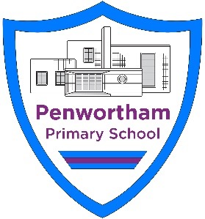

Penwortham Primary School

Science Policy

Date of Policy: October 2023
Policy Review Date: October 2026

Science Policy

Intent Statement
At Penwortham Primary School our vision is to provide a challenging and purposeful science curriculum that is engaging, and enquiry leads to nurture the children’s natural curiosity.
We aim to inspire our young scientists by encouraging them to be hands on, make links to real life, challenge stereotypes as well as building upon their own prior knowledge and learning across the curriculum.
Our school values create a safe environment where pupils encounter a curriculum which supports, builds resilience and challenges all.

Implementation
Scientists in Penwortham Primary School:
- Are curious and enthusiastic.
- Use scientific vocabulary and prior knowledge to enhance independent learning.
- Ask questions to find out more about the world and real life science.
- Are active and practical learners when investigating.
- Know and use the different types of scientific enquiry.

Planning and Resources
Planning is a process in which all teachers are involved. We use the Associate of Science Education’s ‘Planning Matrices’, alongside our curriculum map. Our planning includes scientific enquiry, practical work and the opportunity to work scientifically. The curriculum is designed to ensure that your children encounter the knowledge in the National Curriculum and Statutory Framework in a sequence that builds appropriately over time on prior learning.
Further evidence of ‘good science’ taking place in classrooms includes:
- An active learning environment and relevant Working Scientifically posters for age phase on the working walls during science topic coverage.
- Children being encouraged to ask and answer questions and discuss their work and ideas.
- Children devising and conducting their own investigations within the context of the relevant curriculum content, as well as being given opportunities to develop their working scientific skills.
- Children record their findings in a variety of ways.
- Children show enjoyment in the activities they are undertaking.
- Add to our resources and facilities using opportunities presented from Priory Academy through our partnership agreement.
Pupils should read and spell scientific vocabulary at a level consistent with their increasing word reading and spelling knowledge at all stages.

Organisation
Science will be taught in planned topic blocks by the class teacher, this has been designed and adapted by our staff to have a cross curricular approach that fits in with the half-termly topic whilst ensuring full coverage of the National Curriculum. In most instances this would be a weekly science lesson.
- Resources are held in the central store area for science inside the Year 1 classroom. Additional resources are available by requesting them from the science subject leader at the start of the year.
- The Explorify website is used to support teaching and learning, and concept cartoons are utilised to support identification of prior knowledge at the start of a sequence of teaching or to identify misconceptions during the teaching sequence.
- Children to record their learning. Children record learning in science books. A written outcome may not be possible in every lesson. Presentation should follow the school expectations and be in line with other subjects.
- Teachers recording evidence of learning In Reception class recording is also saved using the seesaw app. All classes make use of mind mapping to show learned knowledge over time. This may be in the form of a class floor book or individual to each child in their science book. This also forms part of the assessment for learning.
- Marking Teachers should mark in accordance with the whole-school marking policy.
- Displays in all classes are expected to have a working science wall. This should include vocabulary we expect children to be able to use, a developing knowledge base and resources that may support learning.

Monitoring
The science subject leader monitors teaching and learning through book scrutiny, collection of pupil voice each term as well as formal assessment data annually.

CPD
All teachers have the opportunity to improve their practice through the appraisal process which may identify areas for development. The subject leader is supported through membership of the WRIST cluster of schools with regular subject leader updates. The school also works with Priory Academy to identify ways in which the curriculum can be developed through from Key stage 2 to Key Stage 3.

Impact
Assessment:
Children’s progress is continually monitored throughout their time at Penwortham Primary School and is used to inform future teaching and learning.

Assessment for learning is continuous throughout the planning, teaching and learning cycle. However, children are more formally assessed half termly in KS1 and KS2 using a variety of methods:
- Observing children at work, individually, in pairs, in a group, and in classes.
- Questioning, talking and listening to children.
- Considering work/materials/investigations produced by children together with discussion about this with them (Use of Explorify/Concept cartoons).
- All classes make use of mind mapping to show learned knowledge over time. This may be in the form of a class floor book or individual to each child in their science book. This also forms part of the assessment for learning.
- Use the PLAN assessment to compare our pupils work to expected for that year group alongside the TAPS assessment.
- Staff complete the assessment grids on Sharepoint as each topic is completed.
- Subject leader joins in moderation cluster meetings to ensure that assessment is robust and shares findings with teachers.
Foundation Stage teachers deliver science content through the ‘Understanding of the World’ strand and aspects of the Expressive Arts Design strand of the EYFS curriculum. This involves guiding children to make sense of their physical world and their community through opportunities to explore, observe and find out about people, places, technology and the environment. They are assessed according to the Development Matters attainment targets.
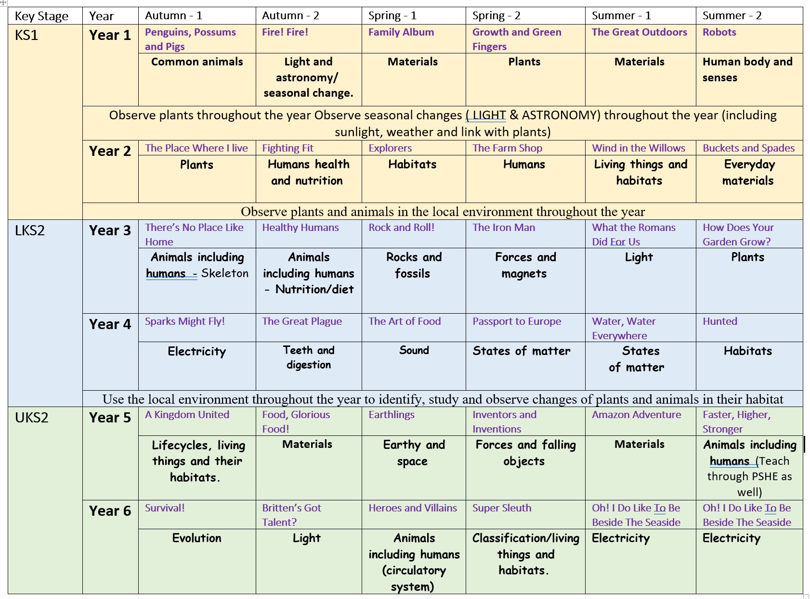
Safety
It is important that the pupils are taught the rules of safety when undertaking experiments that children do this. It is the teacher’s responsibility to ensure that all helpers (TA’s, parents etc.) are aware of safety implications connected with any science activity they are undertaking. Pupils are actively taught to identify possible risks and take steps to control them. Penwortham Primary School is a member of CLEAPS through the Local Authority. Risk assessments are available for science specific teaching and learning on Sharepoint.

Equal Opportunities (e.g. Gender, race)
At Penwortham Primary School we are committed to providing all children with an equal entitlement to scientific activities and opportunities regardless of race, gender, culture or class.

Inclusion (e.g. EAL/SEND/PPG/Provision for HA)
In school we strive to meet the needs of all our children by differentiation in our science planning and in providing a variety of approaches and tasks appropriate to ability levels. This involves providing opportunities for all children to complete their own projects, with support, to develop speech and language skills, as well as scientific skills and knowledge. This will enable children with learning and/or physical difficulties to take an active part in scientific learning and practical activities and investigations and to achieve the goals they have been set. Some children will require closer supervision and more adult support to allow them to progress whilst more able children will be extended through differentiated activities. By being given enhancing and enriching activities, more able children will be able to progress to a higher level of knowledge and understanding appropriate to their abilities. Teachers will use the school’s inclusion planning key to ensure that a range of strategies are used which include and motivate all learners, ensuring that optimum progress is made throughout each part of the lesson.

Parents (Including Homework)
Parental input is highly valued, and parents are regularly invited and welcomed into school to share their own expertise with the children. There are annual science challenges that engage many families in scientific activity. Children may receive science homework based on their current topic.

